Implementing a prototype:

A prototype of a project is sort of a first iteration of it. In this case it is a preliminary model of the software we built, from which other forms can be developed or improved upon.
Here are some screenshots of our prototype:
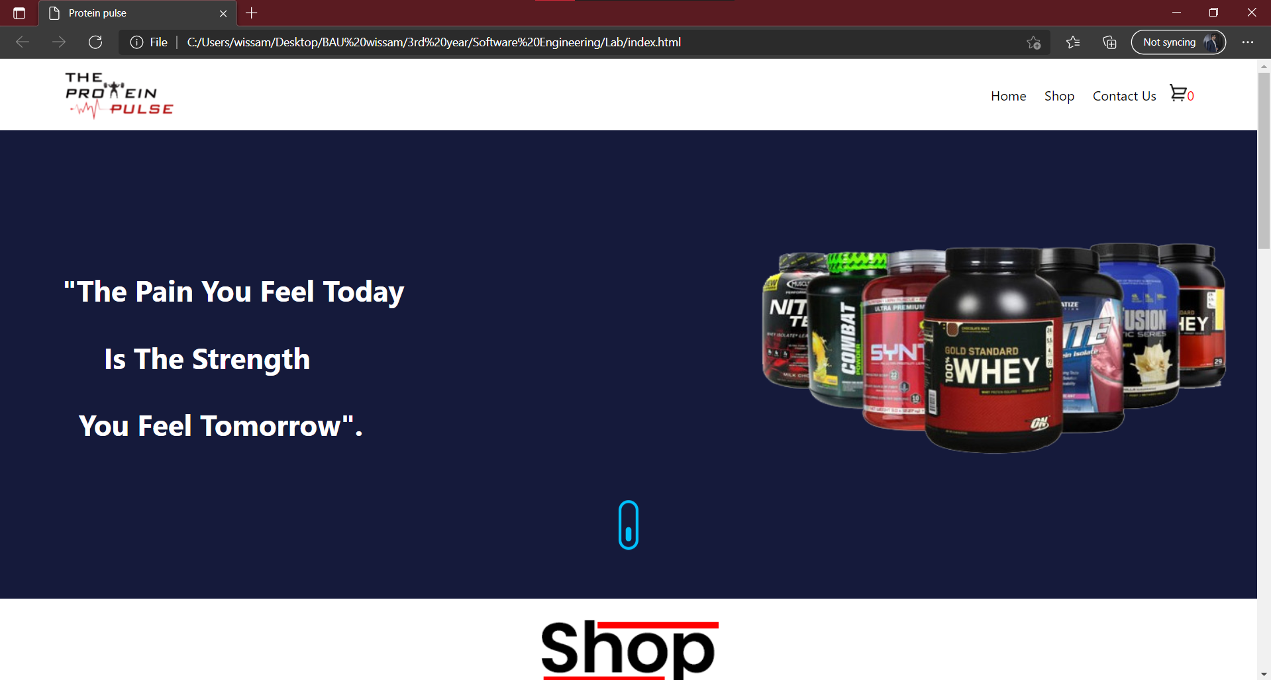
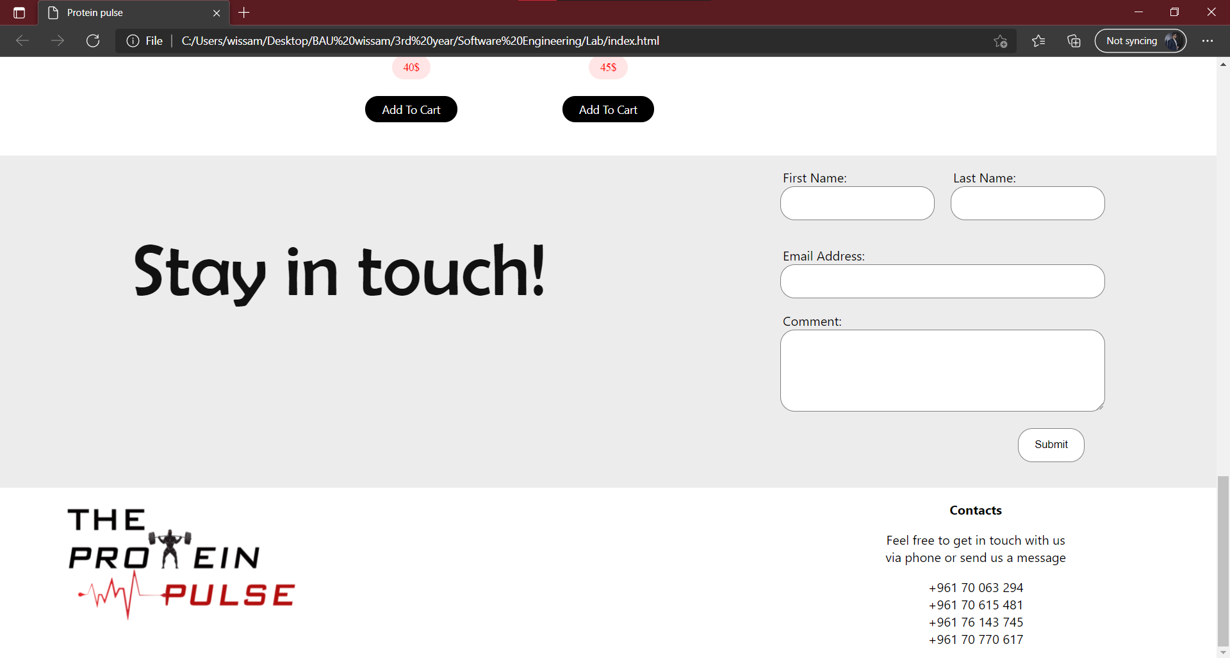
These show an overview of what we have built.

API implementation:

In our program, we have tried to enhance it using API, which can facilitate the communication between apps, create a better user experience and improve the usability of the software.
Since we appreciate the communication between us and the clients or users, we have addedcd the whatsApp API to ease the communication, help if needed and also create a bond with our clients.
Below is a visual explanation of how the API is implemented:
